**Electric Power Company in Valpariso**

**Jesus Eduardo Ortiz Sandoval**

Due to the release of many energy consumption data in the country we can have very important information related to companies that have electricity distribution in the Valpariso region, we can also analyze the type of generation, where the generation comes from, etc.

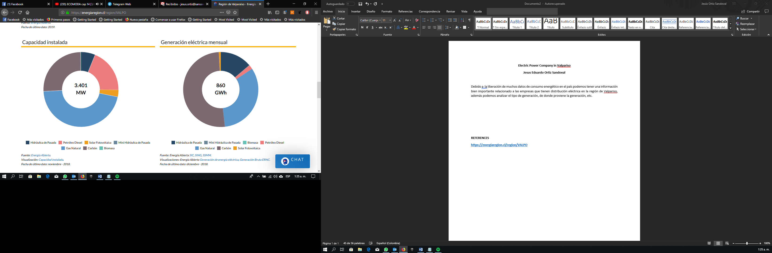

In the previous graph it is analyzed that the installed capacity is mostly generated by natural gas, followed by coal and oil, generation based on non-renewable natural resources, while solar energy, and other types of source, are equivalent to a very small portion. of installed capacity. While in the monthly generation, the generation with contaminating elements and the almost negligible impact of green energies is much more notable.

|  |  |
| --- | --- |
| **Distribuidora** | **Cantidad** |
| CGE | 120.830 |
| CHILQUINTA | 585.893 |
| EDECSA | 5.754 |
| EMELCA | 5.992 |
| LITORAL | 59.348 |
| TILTIL | 91 |
| **Total** | **777.908** |
|  |  |

As for the distribution companies, the main one is CHILQUINTA that has almost half a million users, more than 60% of the users of the entire V region, CGE, has a percentage close to 18% and we also find some small companies that have a few users.

**REFERENCES**

[**https://energiaregion.cl/region/VALPO**](https://energiaregion.cl/region/VALPO)

[**http://datos.energiaabierta.cl/dataviews/241319/cantidad-de-clientes-regulados/**](http://datos.energiaabierta.cl/dataviews/241319/cantidad-de-clientes-regulados/)